Attribute | Parameter Value
Item Category | USB connector
Connector Type | Type-A
Standard | USB 2.0
Gender | female
Number of Contacts | 4
Number of Ports | 1

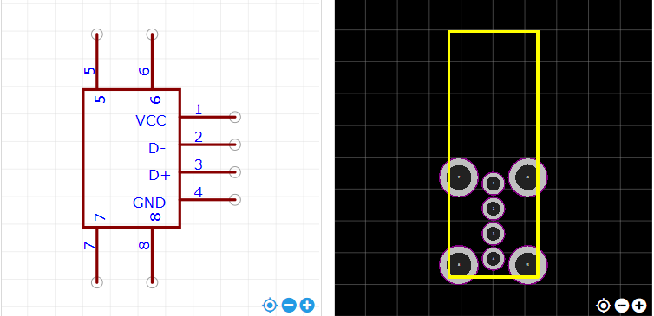

https://item.szlcsc.com/26978.html

